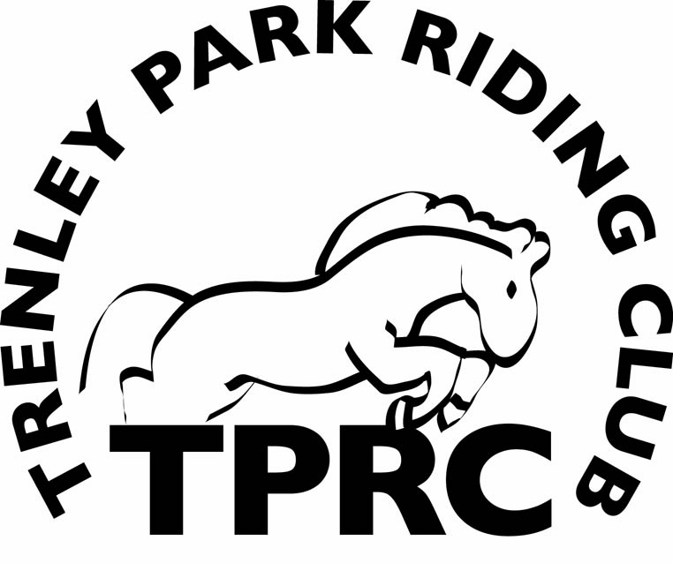

Trenley Park Riding Club
Annual Membership Application Form
Please complete the form in full and return it together with a completed rider registration form and a cross country disclaimer form to the office at Trenley Park Liveries.
Name
Address

Telephone
Mobile
e-mail
Emergency Contact
Relationship

Signature…………………………………………………………………………….
Exams passed (e.g. pony club, BHS, Riding club etc)
……………………………………………………………………………………………………………………………….
Is your horse owned on loan Hired
Name …………………………………………….. Height…………………………
Membership fees 2014
Senior (18 and over) FREE
Non riding member FREE
The annual subscription shall be payable
What is your main interest?
Show jumping Dressage X Country Hacking

Beach rides

We rely on help from members to enable us to run events and all members are encouraged to help at least once a year with various events.
Yes I am willing to help from time to time…………………………………………………………….
I acknowledge that riding is a risk sport and participation may hold potential danger and that all horses may react unpredictably at times. I understand that I must comply with Riding Club safety rules, and obey the instructions of instructors or officials when participating in club activities. If I have concerns regarding safety issues I will inform a member of the committee as soon as possible.
I agree to accept and abide by TPRC rules………………………...(Signed) Date …………………
NOTES: Only Membership Forms accompanied by the correct fee will be processed.
Club records are held on a computer to ease data handling and administration.
New members applications are considered at Committee meetings held on the 2nd Thursday of every month

